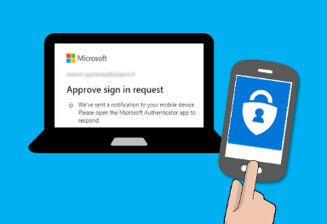
Multifactor Authentication (MFA)

What is MFA?
Multifactor authentication. Setting up MFA adds an extra layer of security to your Microsoft 365 account sign-in. For example, you first enter your password, and, when prompted, you also type a dynamically generated verification code provided by an authenticator app or sent to your phone

- Install Microsoft Authenticator from your App Store or Play Store.
- Open Microsoft Authenticator, skip all initial notices, and click Add Account
- Choose Work or School Account
- Select Sign In
- Your phone will prompt for a Microsoft login. Use your SETU credentials (StudentID@setu.ie) and Password.
- Select Open Browser
- Input your SETU username and password again
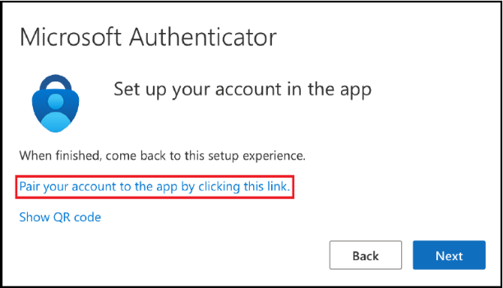
- On the “Start By Getting The App” screen, click “Next”
- On the “Set Up Your Account In The App” screen, click “Pair your account to the app by clicking this Link” and click “Next”

- Wait for activation to complete and click “Finish”

What Happens Then?
When you try to access your mail, OneDrive, Core, etc., from outside of the college network, you will get prompted to enter MFA details or approve them from the authentication app. You will have the option to remember these MFA details for 30 days.

***Please Note: If you encounter any issues or change your device, please contact ITServices.cw@SETU.ie***

