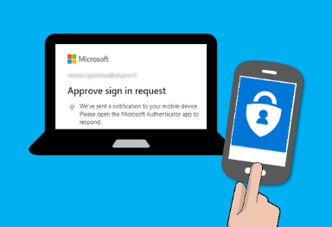
Multifactor Authentication (MFA)

What is MFA?
Multifactor authentication. Setting up MFA adds an extra layer of security to your Microsoft 365 account sign-in. For example, you first enter your password, and, when prompted, you also type a dynamically generated verification code provided by an authenticator app or sent to your phone

Step 1: On Your Phone:
- Install Microsoft Authenticator from your App Store or Play Store.
- Open Microsoft Authenticator, skip all initial notices, and click Add Account
- Choose Work or School Account
- Select Scan a QR code (grant permissions to access the camera if necessary)

Step 2: On Your PC/Laptop:
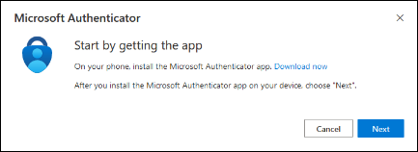
- Browse and login (using your usual SETU credentials StudentID@setu.ie) to: https://mysignins.microsoft.com/security-info
- On the Start by getting the app screen, click Next

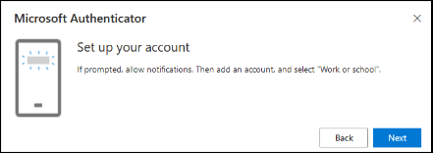
- On the Set up your account screen, click Next
- You will be shown a QR code

Step 3: On Your Phone:
- Position the camera on the phone over the QR code on the monitor. (Alternatively, you can manually enter code and URL).
- Once the QR code capture was successful, Click “Finish” and the phone will add the SETU MFA account to the Authenticator App.

Step 4: On Your PC/Laptop:
- Click “Next”

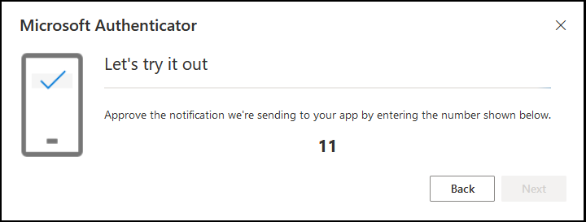
Step 5: On Your Phone:
- Please put in the 2 digit code displayed on your PC/Laptop, into your phone and then click “Yes”

Step 6: On Your PC/Laptop:
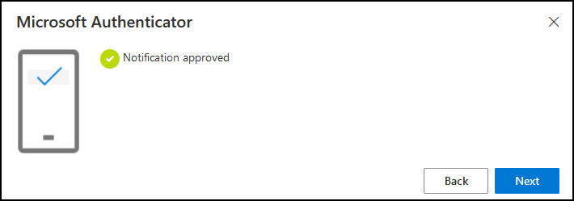
- Your Application connection should be verified when you see this screen
- Click Next

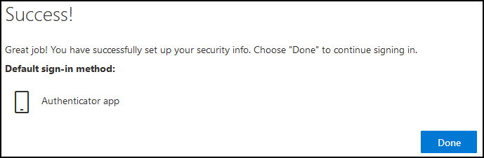
- Once finished, you should see a Success screen like the one opposite.
- Click “Done”

What Happens Then?
When you try to access your mail, OneDrive, Core, etc., from outside of the college network, you will get prompted to enter MFA details or approve them from the authentication app. You will have the option to remember these MFA details for 30 days.

***Please Note: If you encounter any issues or change your device, please contact ITServices.cw@SETU.ie***

