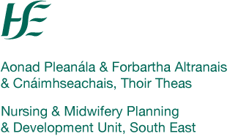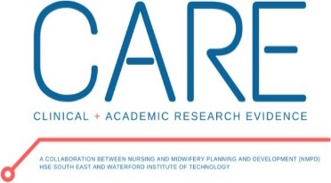

**CARE (Clinical Academic Research Evidence) Collaboration Research Initiative**

**RESEARCH PROPOSAL 2025**

**Deadline: 20.03.2025 @ 5pm**

|  |  |
| --- | --- |
| **Title of Project**  ***(Brief max 12 words)*** |  |
| **\*Proposal Author Name(s)** |  |
| **\*Director of Nursing/Midwifery/Public Health Nursing *(if different from above)*** |  |
| **Proposer(s) Clinical Area/Location Address** |  |
| **Email Address Proposal author**  **Email Address of Director of Nursing/Midwifery/Public Health Nursing** |  |
| **Tel No:** |  |

*\*Please show the primary proposer(s) in* ***bold and underlined font****. Correspondence* ***will only*** *be directed to the primary proposer(s) unless otherwise requested. Submissions may be made from multiple services together, please include all details if relevant.*

|  |
| --- |
| **Brief Rationale *(Why?)*** |
| ***Guide for applicants:*** *Please ensure that the rationale is based on either an identified clinical problem/challenge or the evidence gap that currently exists. You can align the rationale with reference to the key relevant strategies/policies e.g. OMNSD Research Priorities Document, Slaintè Care, Advanced Nurse Practice, Clinical Nurse Specialist Role, HSE Research Priorities. Develop the rationale with a focus on (1) The problem with respect to existing service and/or population health; (2) The contribution of the proposed to nursing and midwifery knowledge and/or the impact to clinical practice, services or a specific population.* |
| ***Limit: 300 words*** |
| **Project Aim & Objectives (*What?)*** |
| ***Guide for Applicants:*** *The* ***aim of the research,*** *make the aim as clear and uncomplicated as possible. It may help to try phrasing it as a question to start with. Imagine that you're writing the aim for someone who knows nothing about what you're doing or proposing. The****objectives of the research****should then be listed, these are simply the steps by which the aims are going to be achieved.* |
| **Aim:**  **Objective:**  ***Limit: 120 words*** |
| **Proposed Approach/Method *(How?)*** |
| ***Guide for applicants:*** *give some thought to the practicalities of your research and have a basic methodological plan. Consider: the three types of methodology qualitative, quantitative, and mixed methods, what research instruments or tools you propose to collect and analyse the data in your proposal. .* |
| ***Limit: 150 words*** |

|  |
| --- |
| **Please detail if this proposal has been developed with support from academic partner** |
| ***Guide for applicants****: Detail name and title of academic partner if applicable; please mark N/A if not applicable.* |
|  |

|  |  |
| --- | --- |
| **To be completed by Director of Nursing/Midwifery/Public Health Nursing**  **\*\*This section is required for the proposal to be submitted to CARE Collaboration Committee** | |
| **\*\*Please outline your support for this proposal.** | |
| **Name:** | **Location/service:** |
| **Signature:** | |

For more information or support with your proposal, contact Ms. Tracey Dermody, Post Graduate Research Support Officer, Department of Nursing and Health Care, Room 108 O’Connell Bianconi Building, SETU (South East Technical University), Cork rd., Waterford. +353 87 2105828 (mob).[**Tracey.Dermody@setu.ie**](mailto:Tracey.Dermody@setu.ie)

**Completed Proposals to be emailed to Margaret Hickey, with subject heading**

**‘CARE Collaboration Proposal 2025’**

**Email:** [**margaretm.hickey@hse.ie**](mailto:margaretm.hickey@hse.ie) **and cc**[**Tracey.Dermody@setu.ie**](mailto:Tracey.Dermody@setu.ie)